Shipping Instructions for US Ground Excepted Lithium Ion Battery Packs
- Introduction
This document provides recommendations for shipping lithium ion battery packs to DEWALT Service Centers using the US Ground Excepted Lithium Ion Battery Shipping Kit, Part No: 5140240-04. Each pack in the shipment must be ≤ 300 Watt-hours (Wh) in energy capacity and must not be, or suspected to be Damaged, Defective or Recalled (DDR). It is the shipper’s responsibility to understand and comply with the latest regulations and requirements for shipping lithium ion batteries.
- Scope
The shipment of lithium ion batteries by ground within the US is governed by the US Code of Federal Regulations (CFR) Title 49 Part 173.185, (49 CFR 173 Shippers - General Requirements for Shipments and Packagings). Battery packs ≤ 300 Wh that are not determined to be Damaged, Defective or Recalled (DDR) are considered Excepted and do not need to be shipped as fully regulated Dangerous Goods when these procedures are followed.
- Shipper’s Responsibilities
As the shipper of Excepted lithium ion batteries, you must ensure that each of the following conditions are met prior to presenting the package for shipment according to this procedure:
The answer to each question must be YES to use this shipping procedure. | YES | NO
1. Each battery pack contained in this shipment is ≤ 300 Wh.
All lithium ion battery packs are required to have the Wh energy capacity marked on the pack. DEWALT® battery packs typically have this information on the bottom of the pack as shown in Section 4. Example Battery Watt-hour (Wh) Labels
2. Each battery pack contained in this shipment must not be Damaged, Defective or Recalled (DDR) or suspected of being DDR.
See Section 6. What is a Damaged, Defective or Recalled (DDR) Lithium Ion Battery?
3. Each battery pack contained in this shipment must be placed in a sealed poly or plastic bag.
4. Each Flexvolt ™ battery pack contained in this shipment must have the Shipping Cap installed.
Do not remove the shipping cap if it is already installed on the pack.
5. The gross weight of the finished package must be ≤ 66 lbs (30 Kg).
Note: if the answer to any of these questions is no, please contact a DEWALT® Service Center for assistance.
Note: If you suspect that you have a DDR lithium ion battery, please immediately contact a DEWALT® Service Center for assistance.

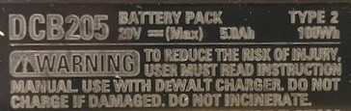
- Example Battery Watt-hour (Wh) Labels​

Battery Watt-hour (Wh) Mark

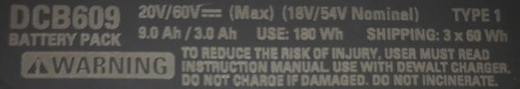

Note: The “SHIPPING” Wh rating on a Flexvolt ™ battery pack is only applicable when the Shipping Cap is installed.
- Shipping Procedure
Note: Please contact a DEWALT® Service Center for questions or concerns regarding this procedure.
- Obtain a US Ground Excepted Lithium Ion Battery Shipping Kit, Part No: 5140240-04 from a DEWALT® Service Center.
- Inspect each battery to be included the shipment to verify that it does not meet the description of Damaged, Defective or Recalled (DDR) as defined in Section 6. What is a Damaged, Defective or Recalled (DDR) Lithium Ion Battery? If there is any indication that the battery pack might meet the definition of DDR, do not ship the pack, set the pack aside and immediately contact a DEWALT® Service Center.
- For Flexvolt™ Packs, verify that the Shipping Cap, Part No: N475920 is properly installed on the pack. Flexvolt packs may not be shipped in this kit without the Shipping Cap properly installed as shown:
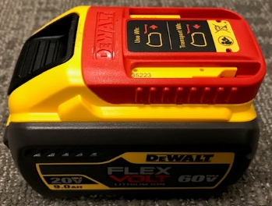
Shipping Cap

- Place each pack into a poly or plastic bag and seal the bag. Acceptable sealing methods include: integral adhesive, adhesive tape or zip enclosures etc.
- Place each bagged pack into the provided carton. Do not overload the carton.
- Once the carton is loaded, use a packing material such as kraft paper, paper cushioning, air pillows, bubble wrap, foam or peanuts etc. to fill the package to secure the packs in the carton.
- Close and securely seal the carton with carton sealing tape, kraft sealing tape or other packaging tape.
- Apply the provided, required labels and markings to the carton as shown below in Figure 1. No other label or mark may be placed over the label and mark shown in Figure 1.
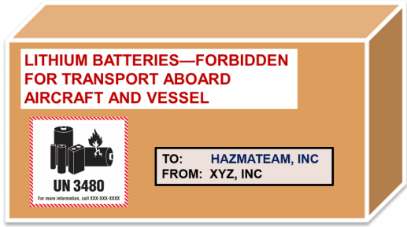

Hazmateam.com
Figure 1
- Weigh the package to verify that the gross weight is ≤ 66 lbs (30 Kg).
- Ship the package according to the standard US ground shipping procedures for your site.
- By presenting the package for shipping, you acknowledge that you understand and are in compliance with the latest regulations and requirements for shipping lithium ion batteries.
- What is a Damaged, Defective or Recalled (DDR) Lithium Ion Battery?​

Damaged, Defective or Recalled (DDR) Battery: Lithium…batteries, that have been damaged or identified…as being defective for safety reasons, that have the potential of producing a dangerous evolution of heat, fire, or short circuit (e.g., those being returned to the manufacturer for safety reasons). 49 CFR § 173.185 - Lithium cells and batteries.
Physical signs of damage include: broken housing components, melted or burnt components or housings or burnt odor, electrolyte leakage or electrolyte odor.
DDR lithium ion batteries are hazardous materials and require special handling and must be shipped according to US DOT Hazardous Materials Regulations. Note: If you suspect that you have a DDR lithium ion battery, please immediately contact a DEWALT® Service Center for assistance.

DDR Lithium Battery Characteristics:
- Physical Damage​
  - Cracked, loose, broken or missing outer enclosure parts that expose metal or cells.​
  - Melted, deformed or charred plastic parts that expose metal or cells.​
- Chemical or Environmental Damage*​
  - Odor, smoke or vapor coming out of the pack​
  - Liquid leaking from the pack. Water or liquid inside the pack.​
  - Corrosion on or inside the pack​
- Electrical Damage*​
- Arcing or sparks produced by the pack​
- Nails, screws or other conductive objects inside or lodged into the enclosure
- Elevated Temperature*
  - Pack housing is hotter than room temperature and the pack was not recently operated in a tool.
* NOTE: If any of these conditions are observed, refer to the attached US DOT PHMSA Emergency Response Guidebook (ERG) - Guide 147 - Lithium Ion Batteries.
- DDR Lithium Battery Examples:

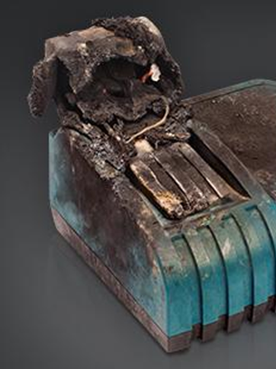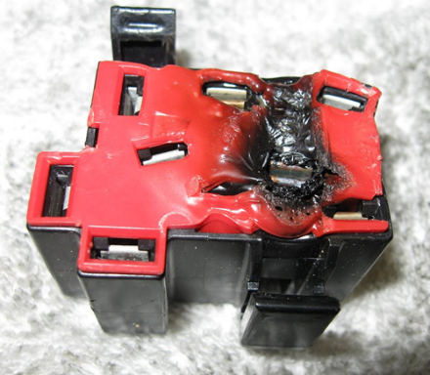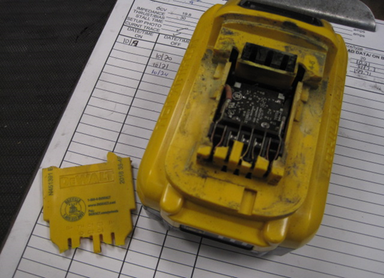
These DDR battery packs show signs of Physical or Elevated Temperature Damage. Do not attempt to insert into a charger or tool. All exposed contacts should be considered live and should be isolated from conductive objects.
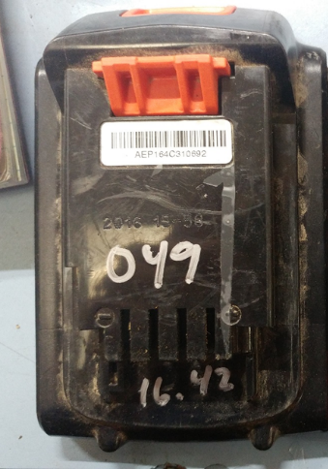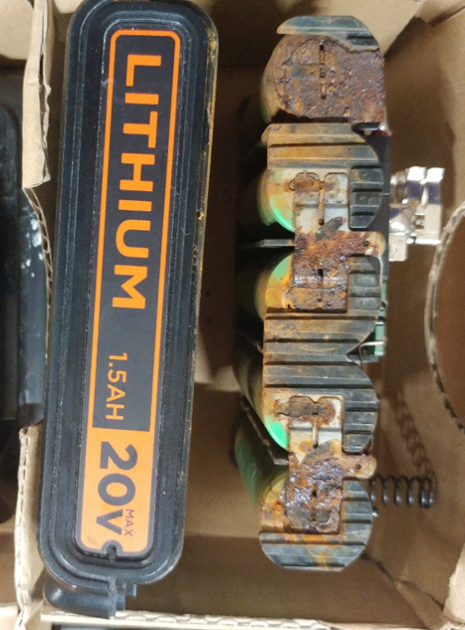
Corrosion Residue
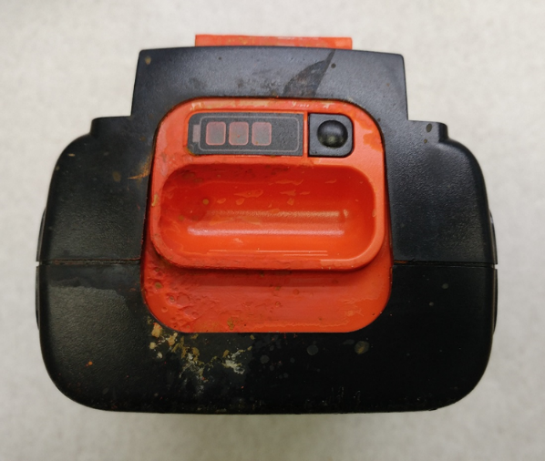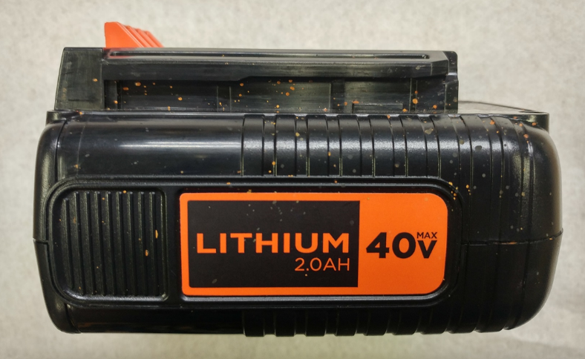
Corrosion
Residue
Corrosion Residue
These battery packs show signs of Chemical or Environmental Damage and have residue from corrosion on the pack housing (rust or green color).
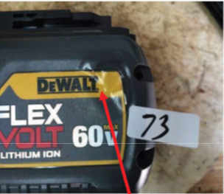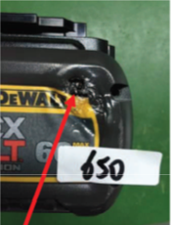
These battery packs show signs of Elevated Temperature Damage and have signs of melting and holes in the battery pack housing.

Attachment 1
