PICTURES SHOWN MAY REPRESENT VARIOUS MODS. SEE WINDCHILL B.O.M. FOR SPECIFIC COMPONENT USAGE.

NOTES:

ROUTING FOR DCS354 / DCS355 / DCS356 MODELS:

TAKE THE LED AND PLACE IT ON THE HOUSING GUIDE AS SHOWN.
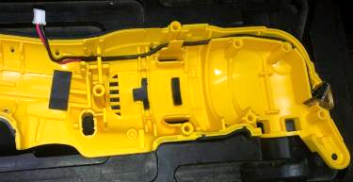

PLACE THE MODULE ON THE HOUSING GUIDES, MAKE SURE IT FITS CORRECTLY

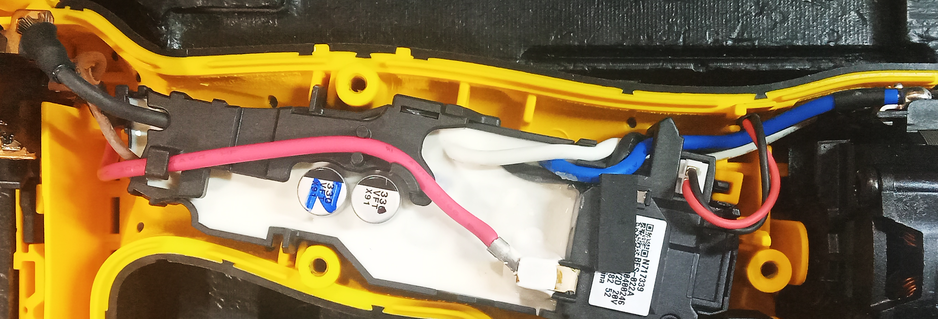

PLACE THE MOTOR WITH THE TERMINALS FACING UP.
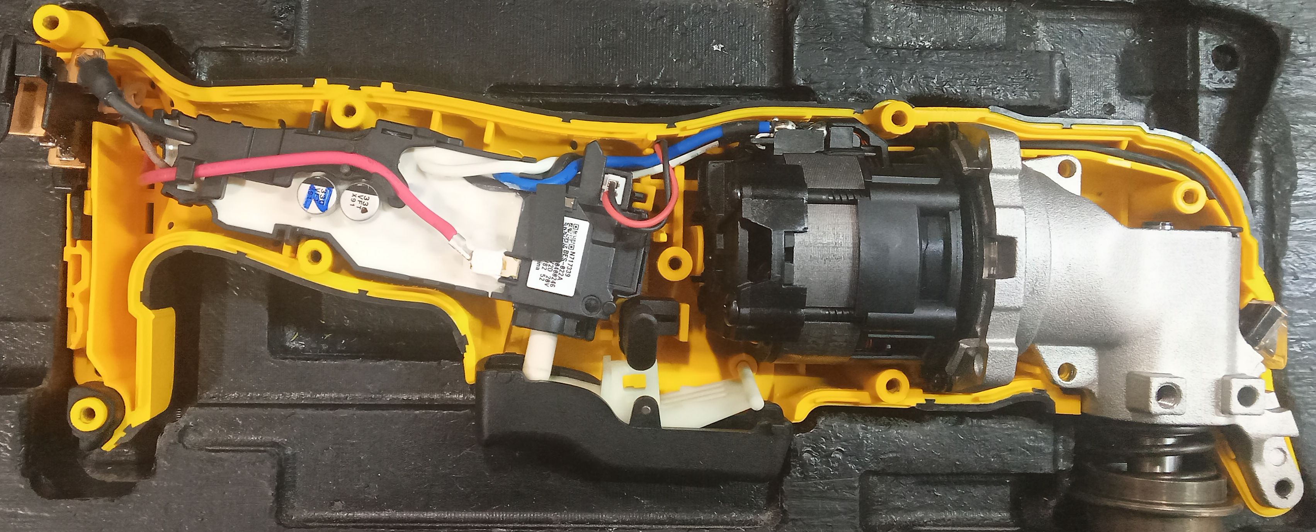

ROUTING FOR DWE315K MODEL:

INSERT THE WHITE WIRE TERMINAL OF THE MODULE INTO THE HOLE SHOWN ON THE SWITCH THEN WITH THE SWITCH IN THE SAME POSITION, INSERT THE BLACK WIRE TERMINAL OF THE MODULE INTO THE HOLE SHOWN ON THE SWITCH

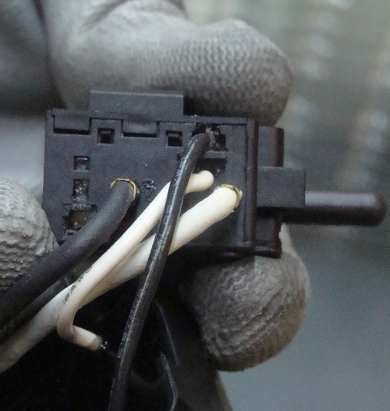
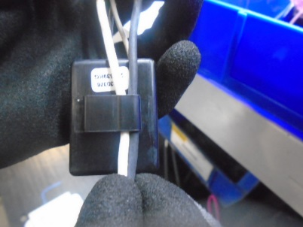

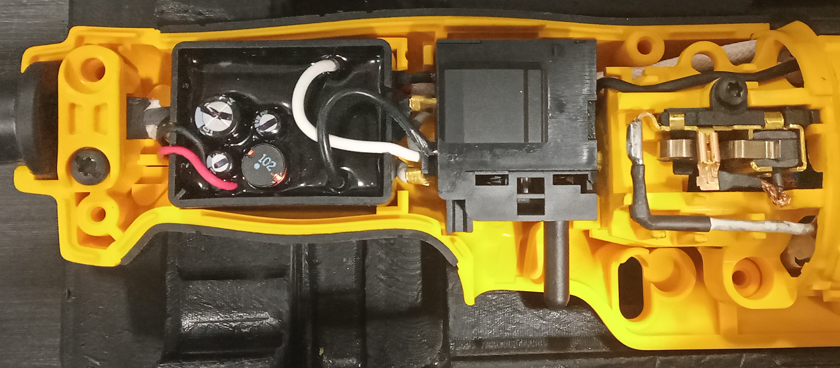
TAKE THE SA MODULE WITH SWITCH AS SHOWN AND PLACE THEM IN THE HOUSING GUIDES.
Field case
Module
Switch
Cord set

