NOTES:

1. DISTRIBUTE TOTAL OF 16.5 – 33.5 GRAMS OF MOLYKOTE G68 GREASE (34138513-00) IN
LOCATIONS NOTED IN THIS DOCUMENT. (Pictures for reference only)

2. DISPENSE MOLYKOTE G68 GREASE AND APPLY TO PARTS AS SHOWN IN PICTURES.

SA CUTTING HEAD

Apply 0.5g +/- 0.2g on Cutter Pin

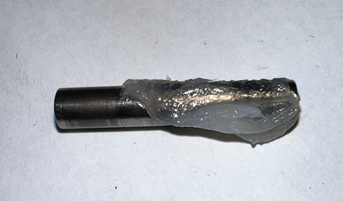

Apply 0.5g +/- 0.2g each on (2X) Roller Pins

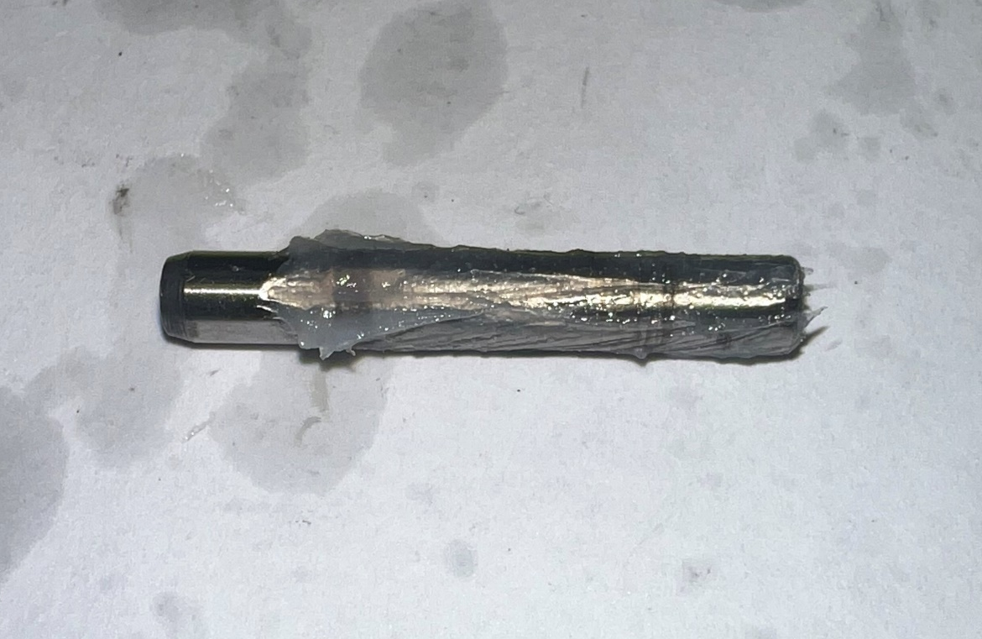

Apply 0.5g +/- 0.2g each to (2X) Cutter Carriage slots

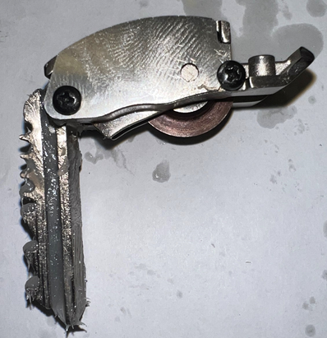

1

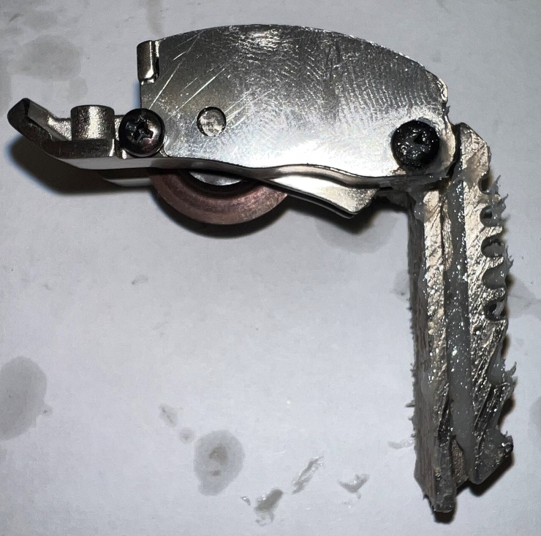

2

Apply 0.5g +/- 0.2g each to (2X) Head Housing slots (ASM and CVR) Roller Carriage rib (2X sides)

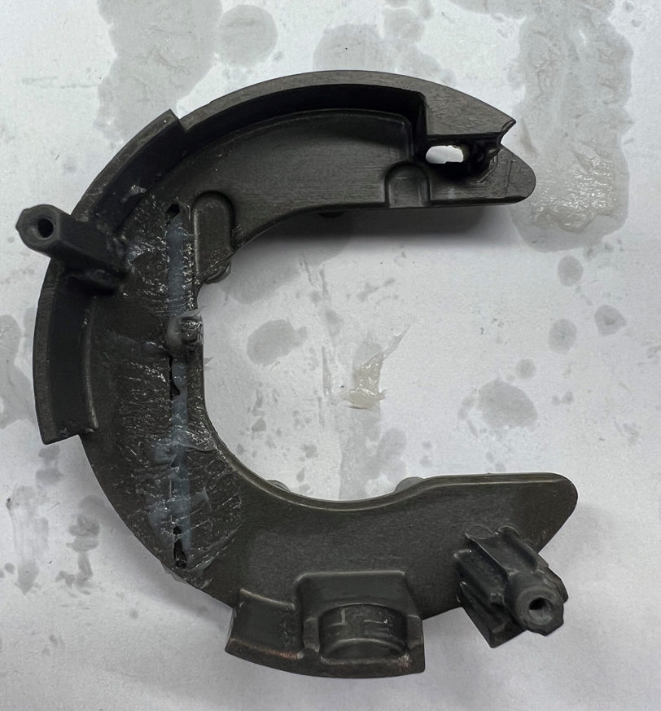

1

SA TRANSMISSION

Apply 2.0g +/- 0.5g each onto (2X) 3rd stage pins and (1X) 2nd stage bushing

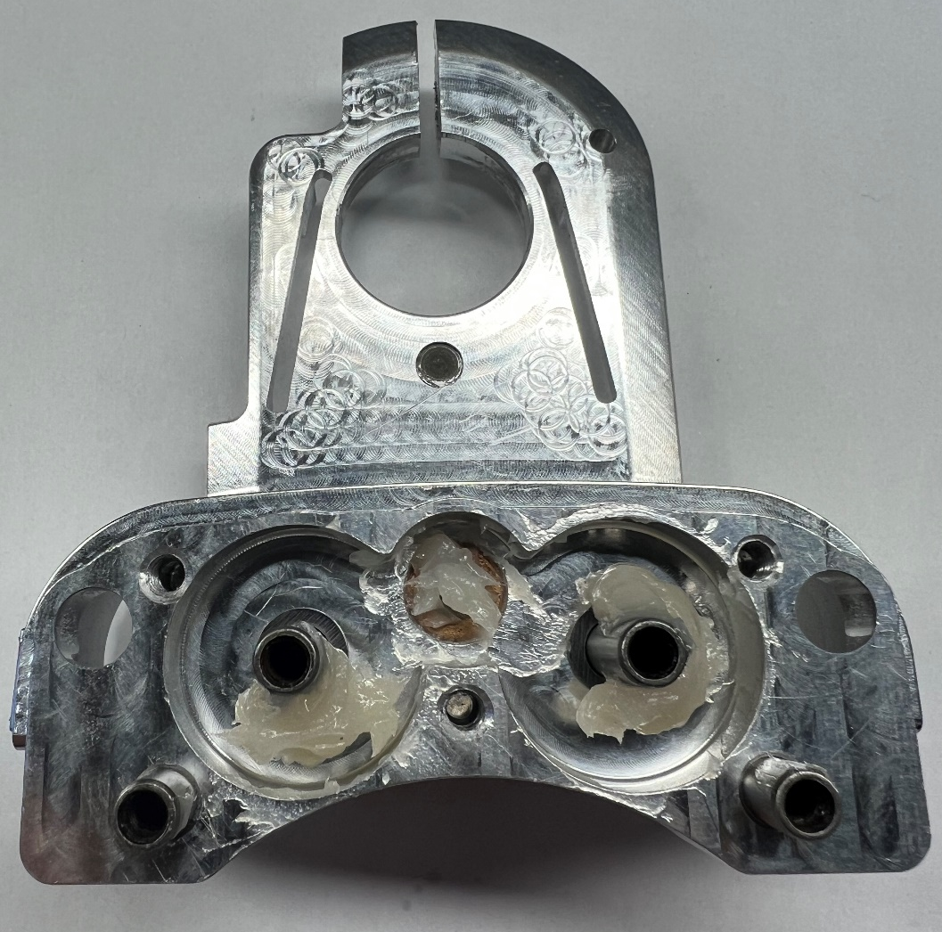

3
2
1

Apply 0.5g +/- 0.2g each onto (2X) 4th stage pins

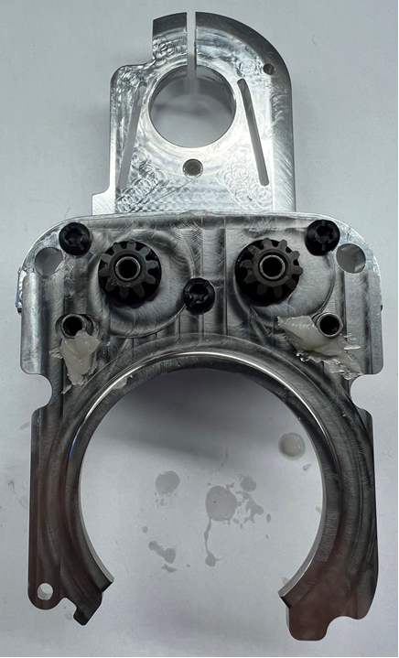

2
1

Apply 1.0g +/- 0.5g total onto Plate rib (ID and OD)

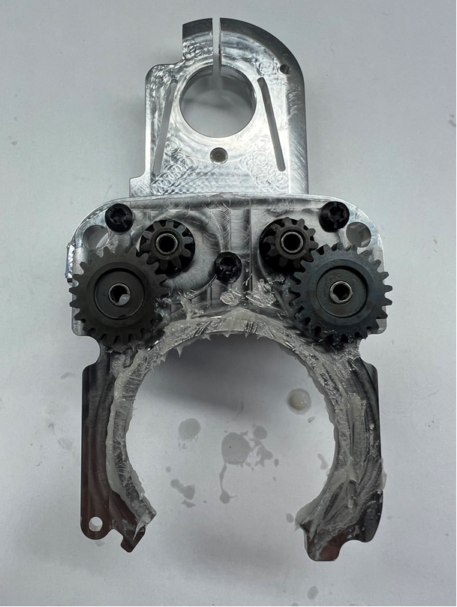

Apply 1.0g +/- 0.5g onto SA Cutting Head surface

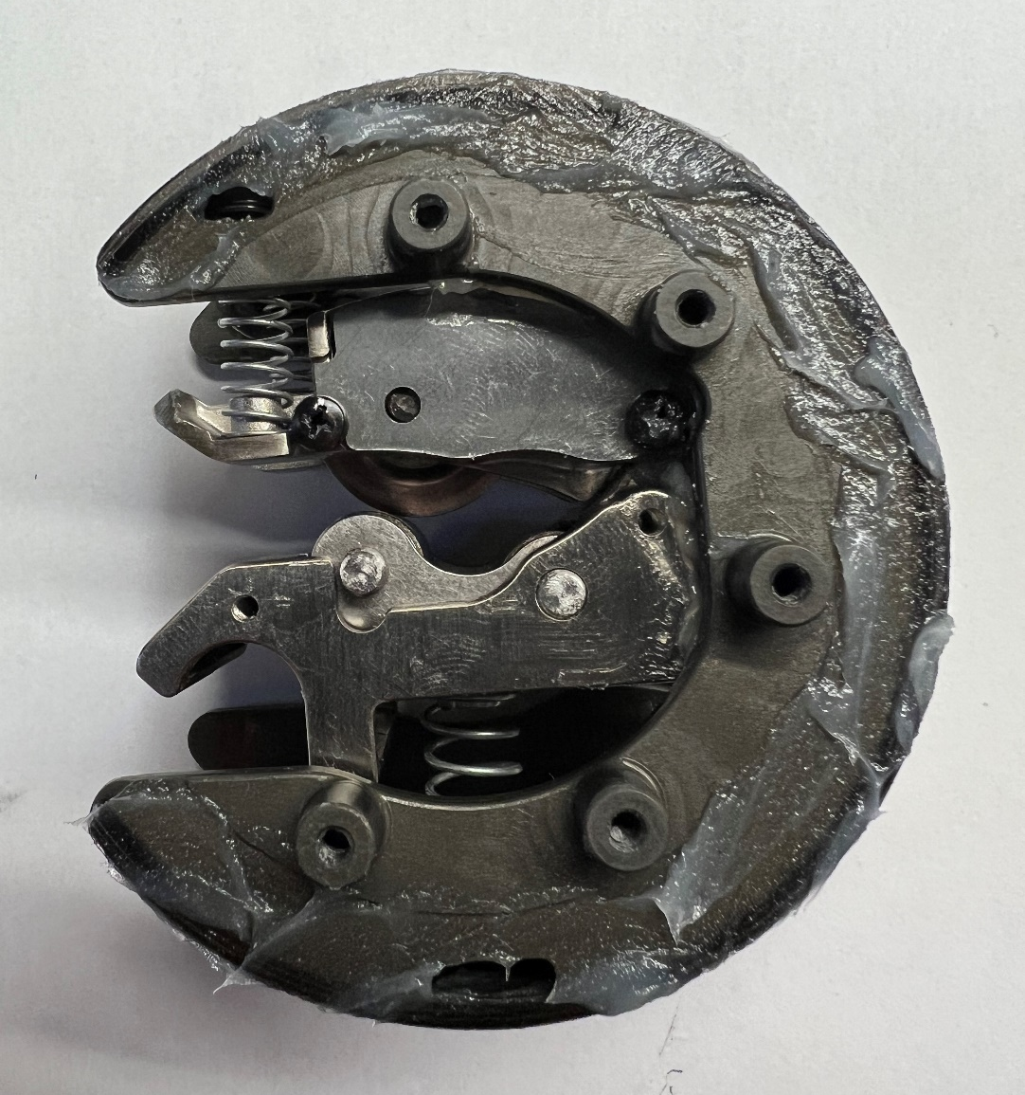

Apply 3.0g +/- 1.0g each between gears in (2X) locations

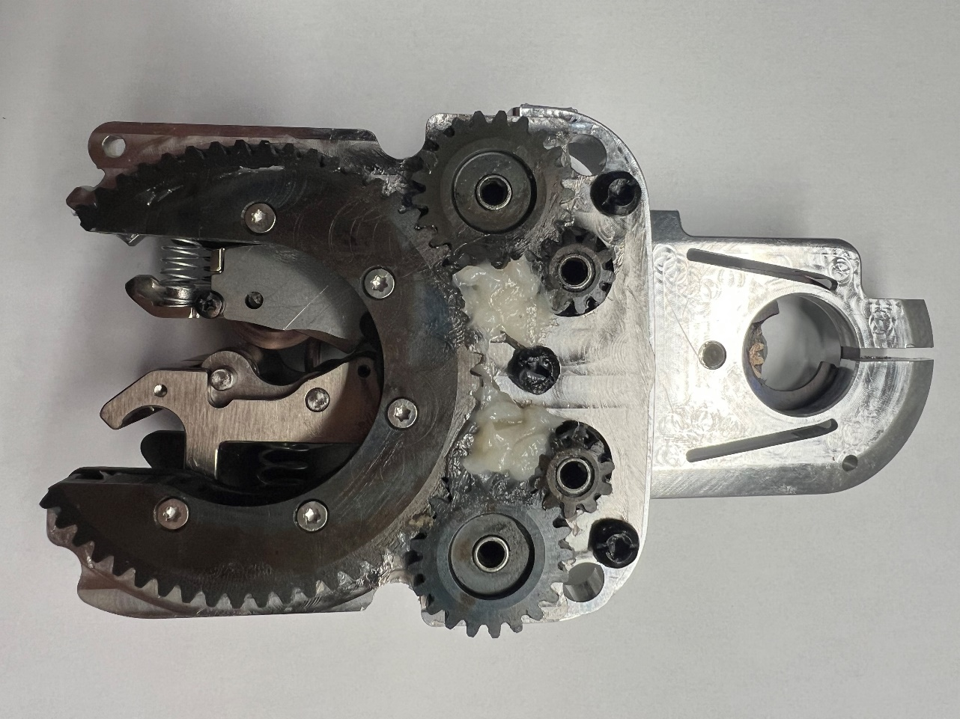

2
1

Apply 1.0g +/- 0.5g total to 2nd Stage Shaft and Bushing

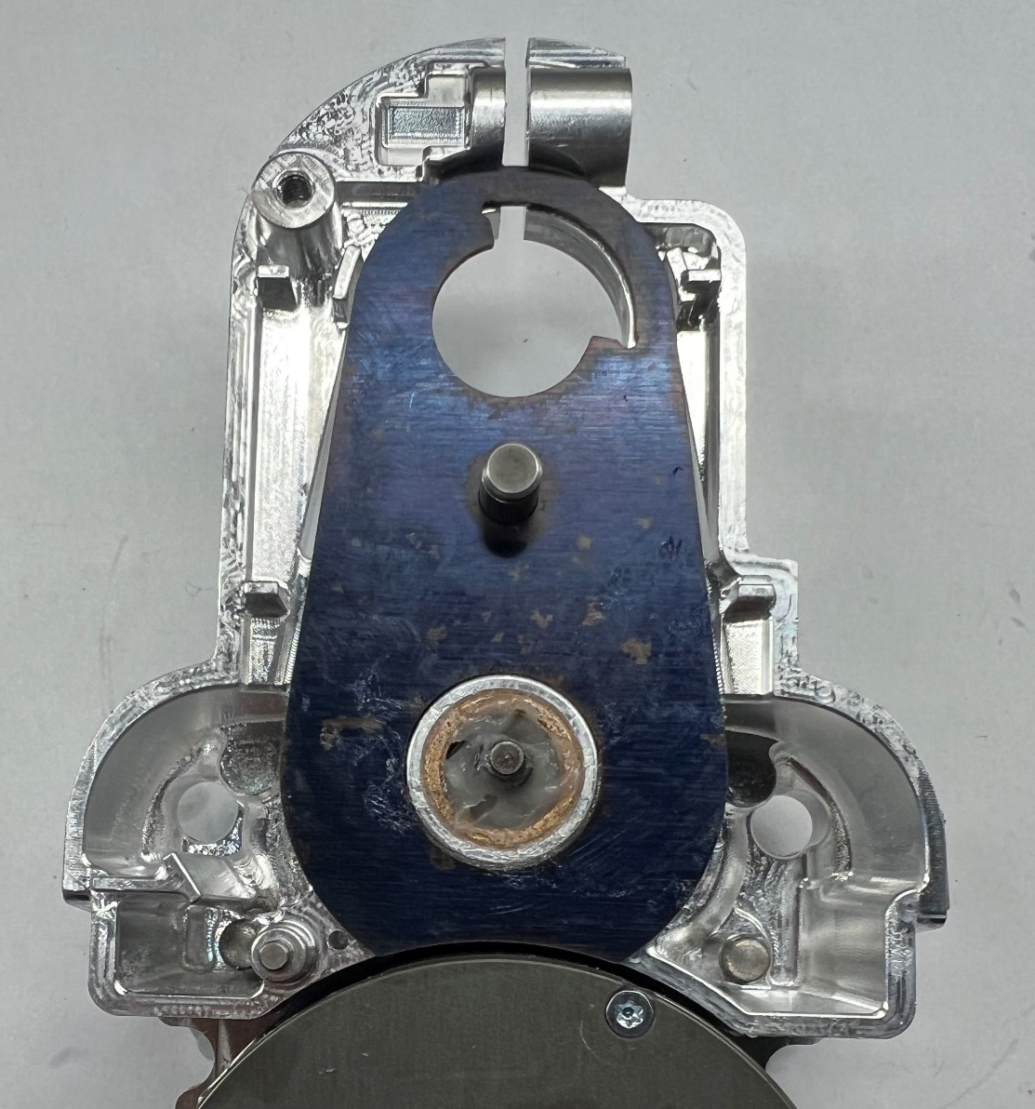

Apply 1.0g +/- 0.5g to Clutch face

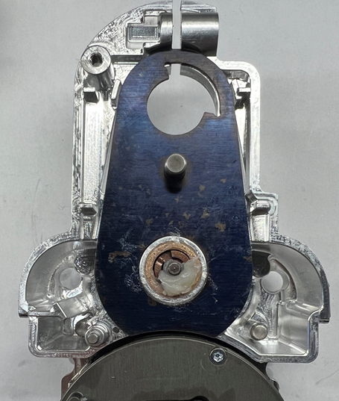

Apply 0.5g +/- 0.2g onto 1st Stage Pin

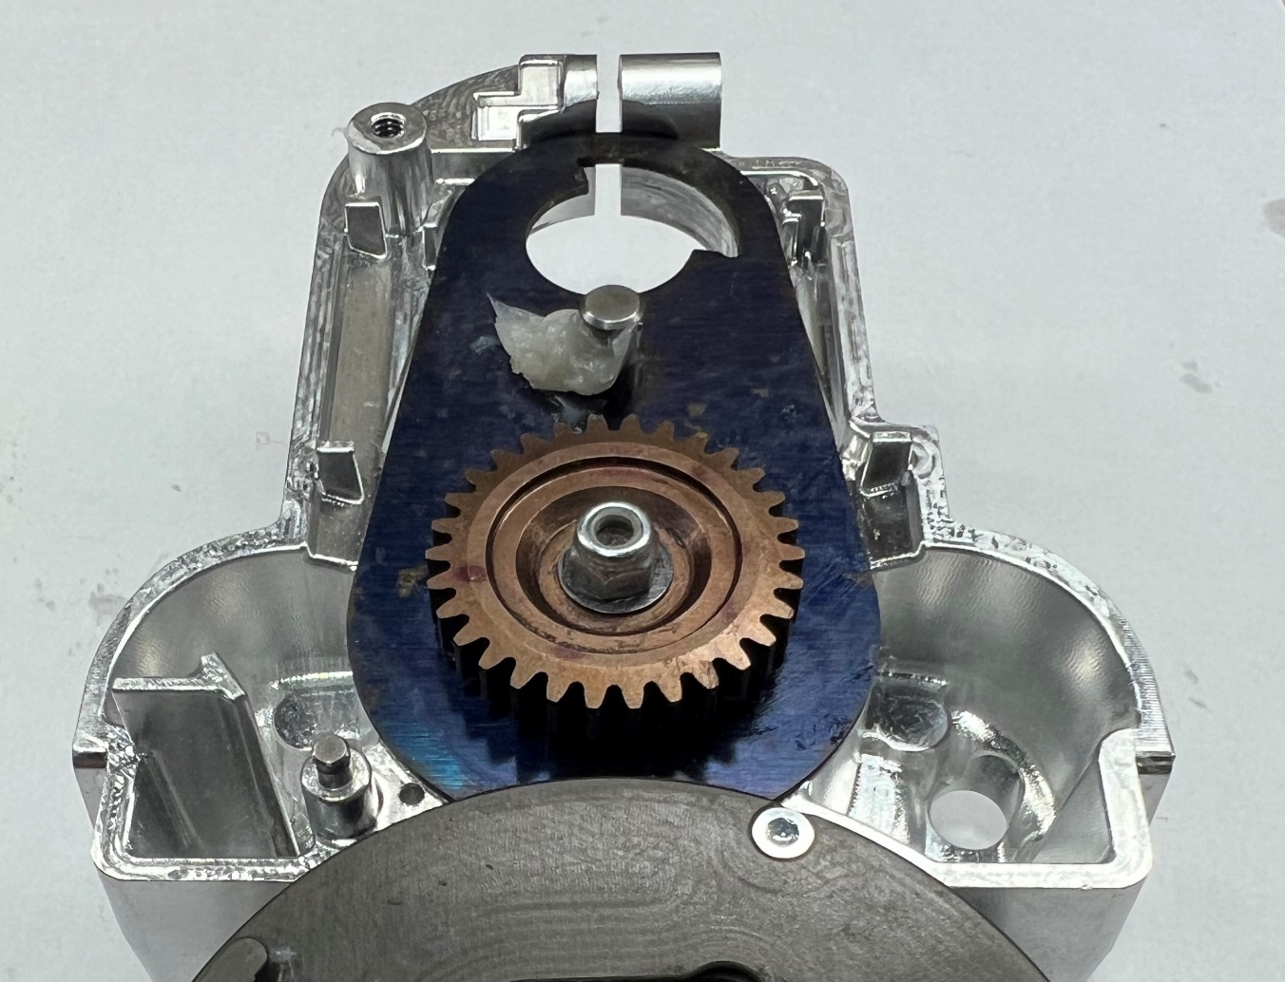

Apply 2.0g +/- 0.5g each between gears in (2X) locations

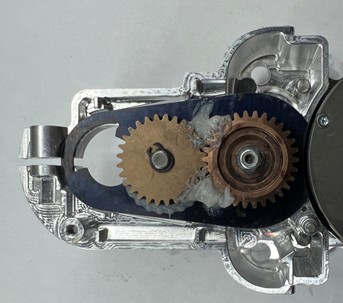

1

2

Apply 0.5g +/- 0.2g onto Ratchet Pin

