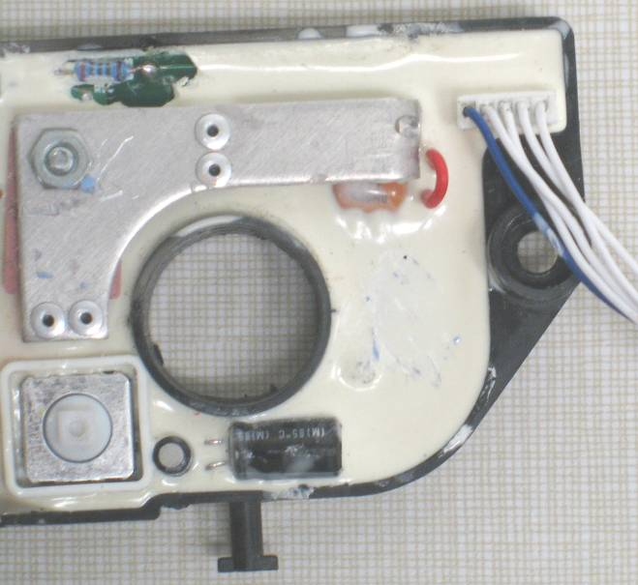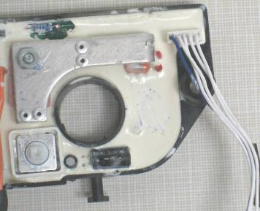
Wire not cut on 18V units DC608 and DC609
Wire cut on 12 volt unit DC602

Shown is the SA Control Module. All modules are received by Black & Decker with the red wire loop intact (for use in 18V units). Wire loop must be cut as shown for use in 12V units.
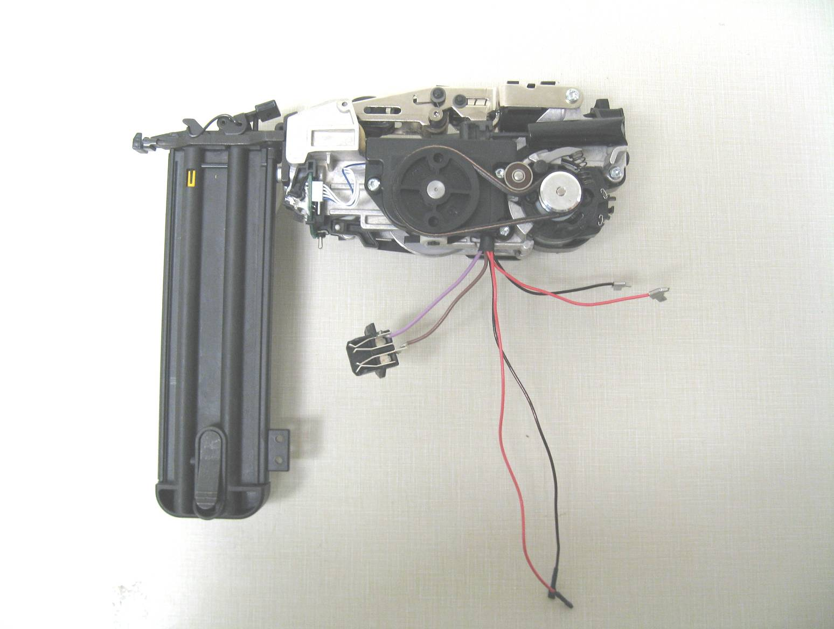

Unit shown before the wire up (SA ENGINE).
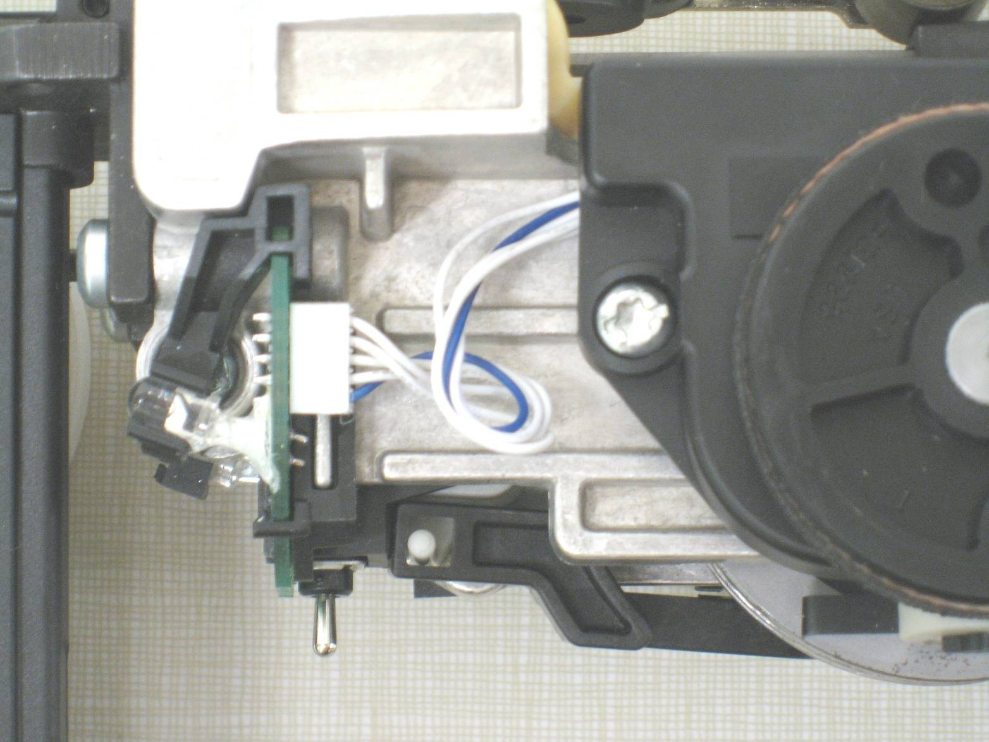
Screw boss

Position the five wire above the screw boss.
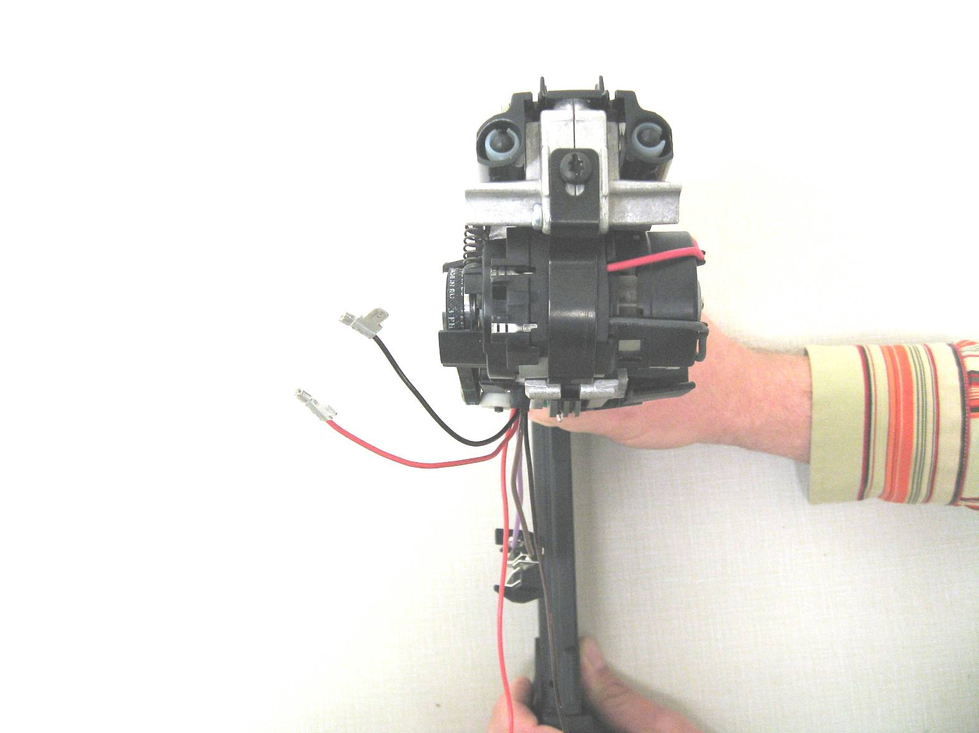
SA Return
SA Engine
SA Motor and Transmission

Top view of unit before placing wires in receptacles.
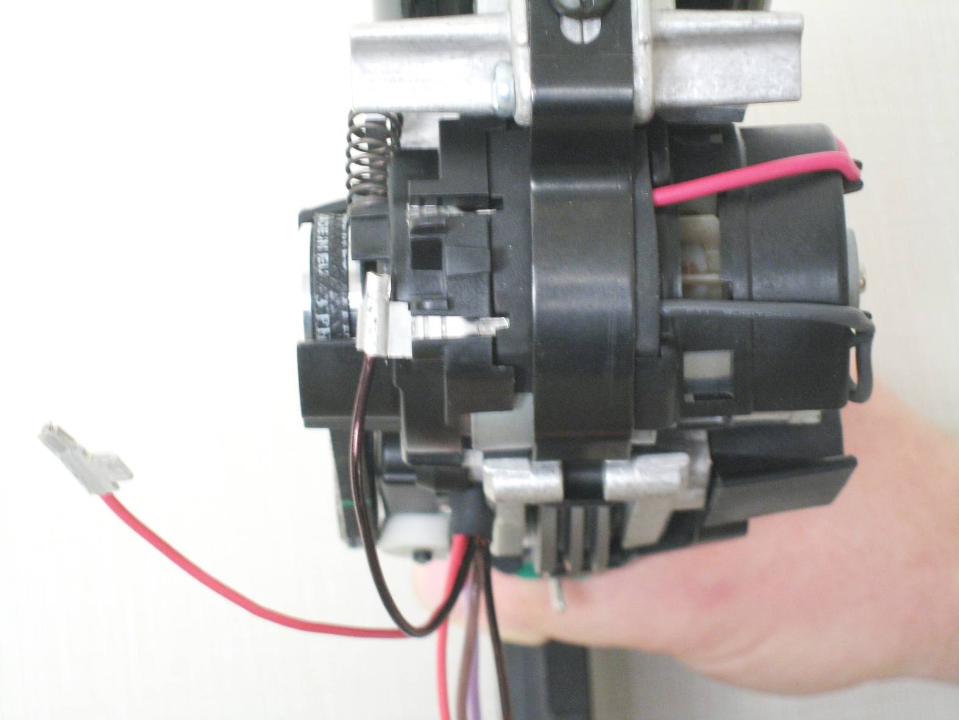

Attach the black wire to the black receptacle (negative to negative).
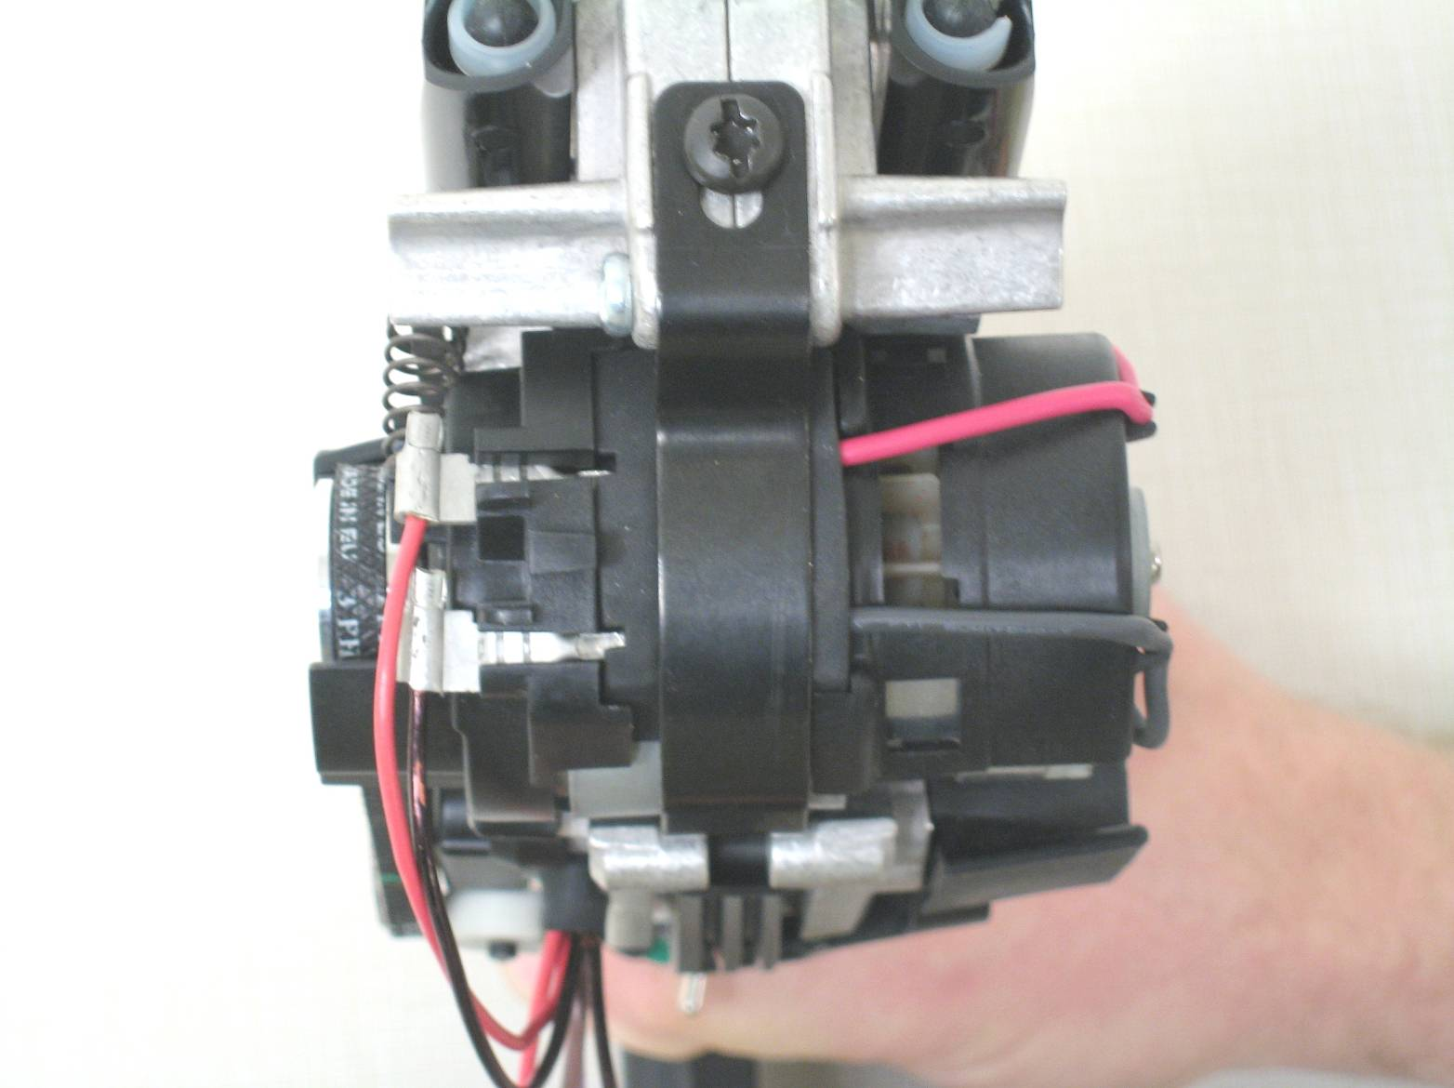

Attach red wire to red receptacle (positive to positive).
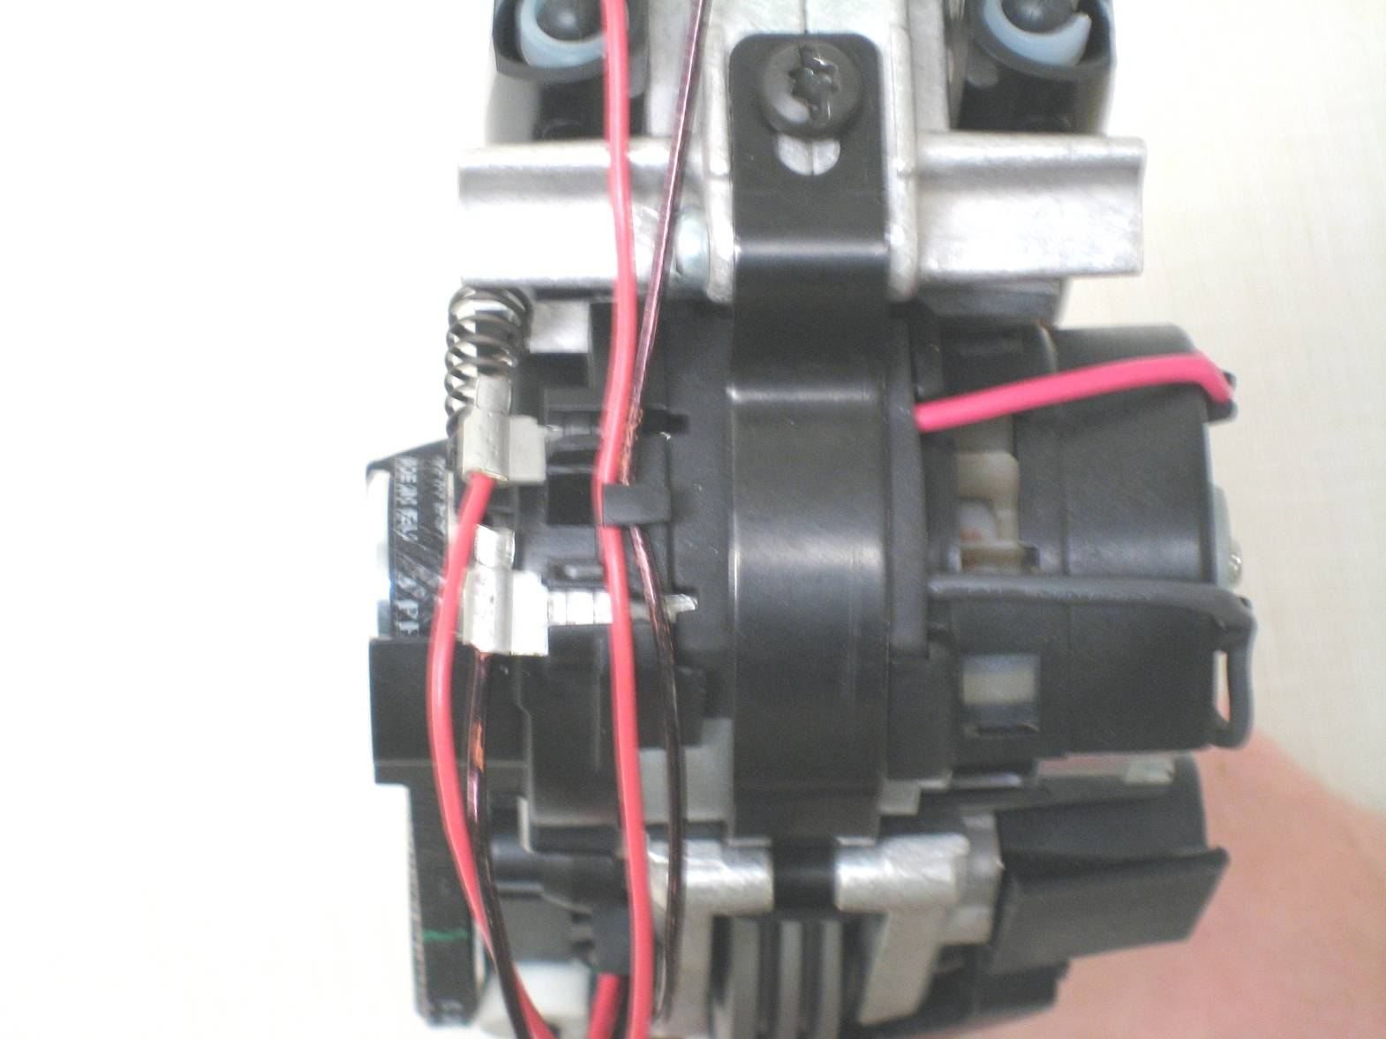
Wire trap

Place solenoid wires in trap on transmission plate.
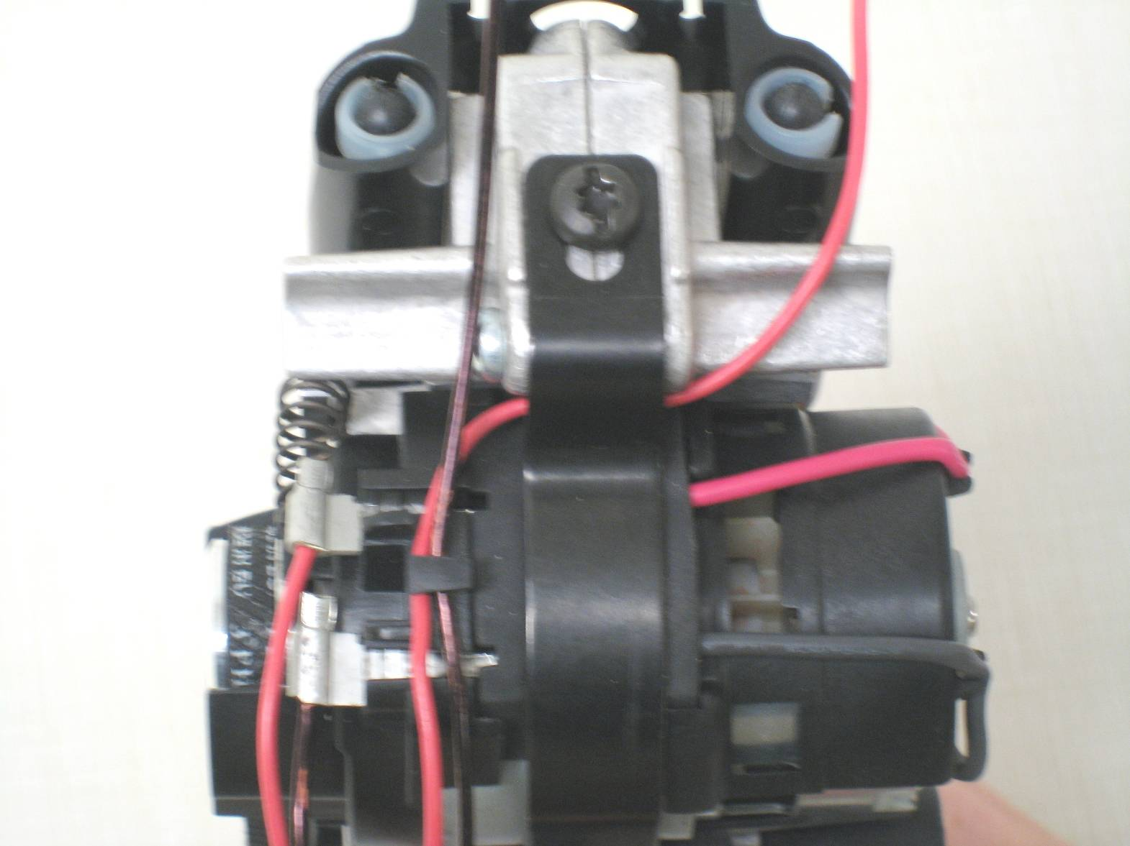

Place one wire under motor strap.
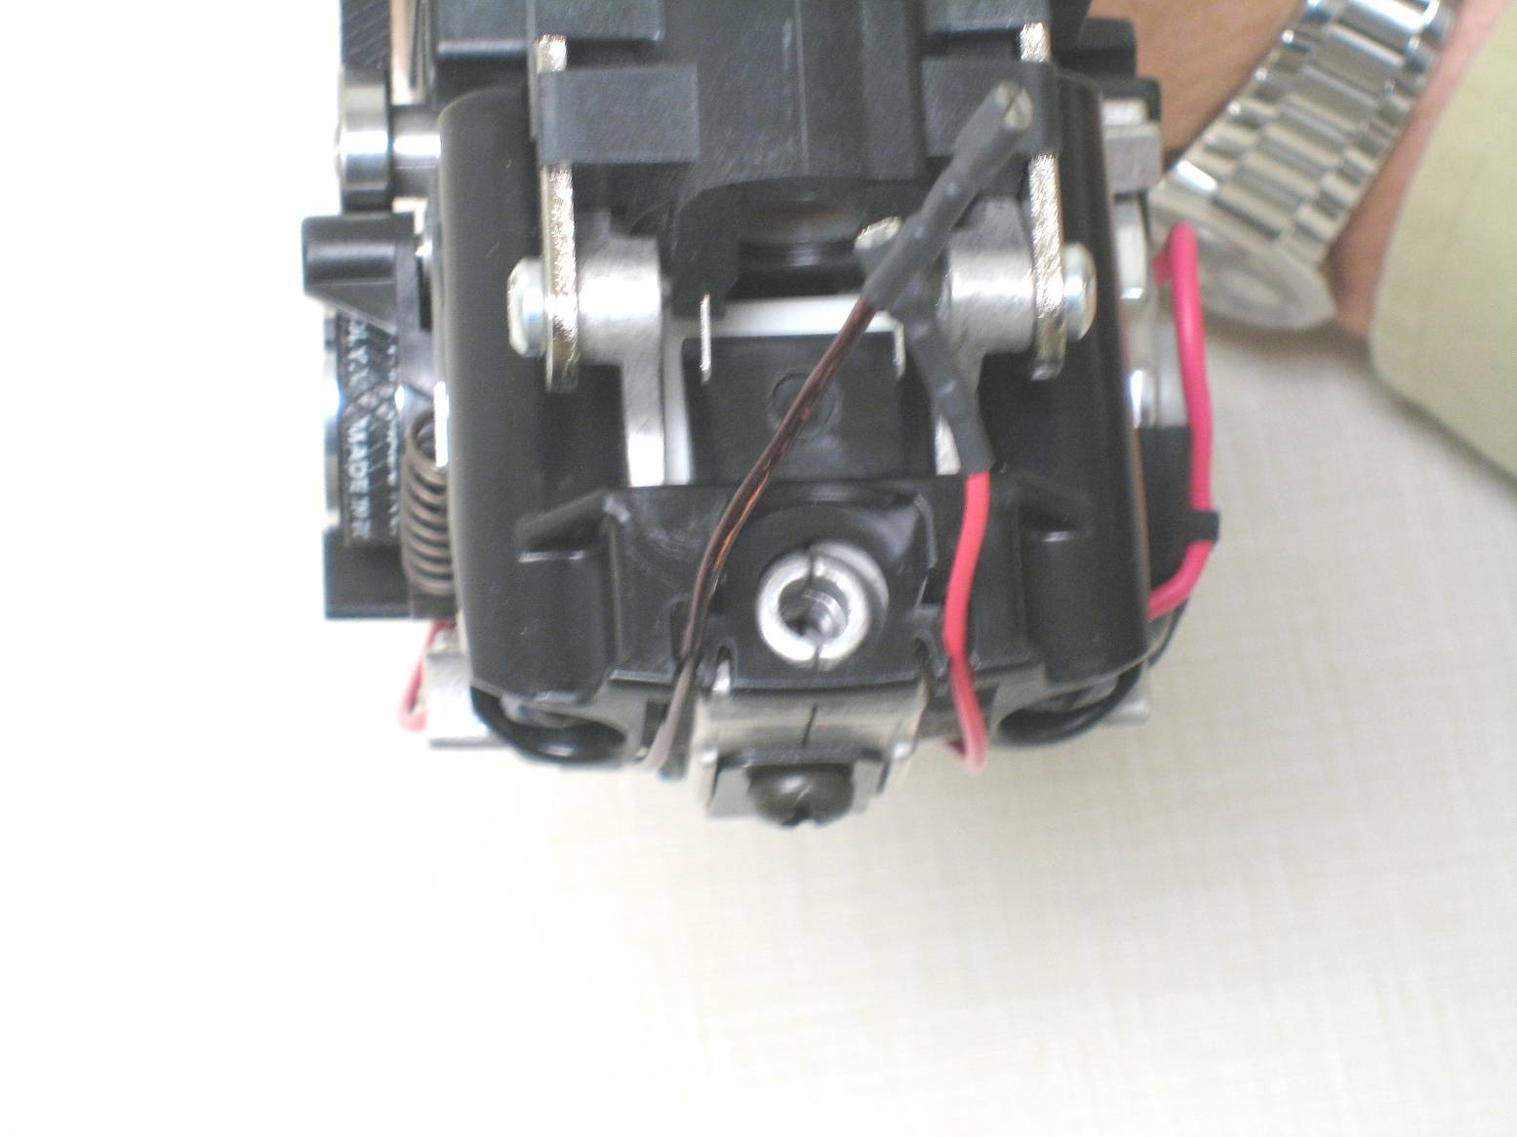
Return housing trap.

Place wires into traps on return housing.
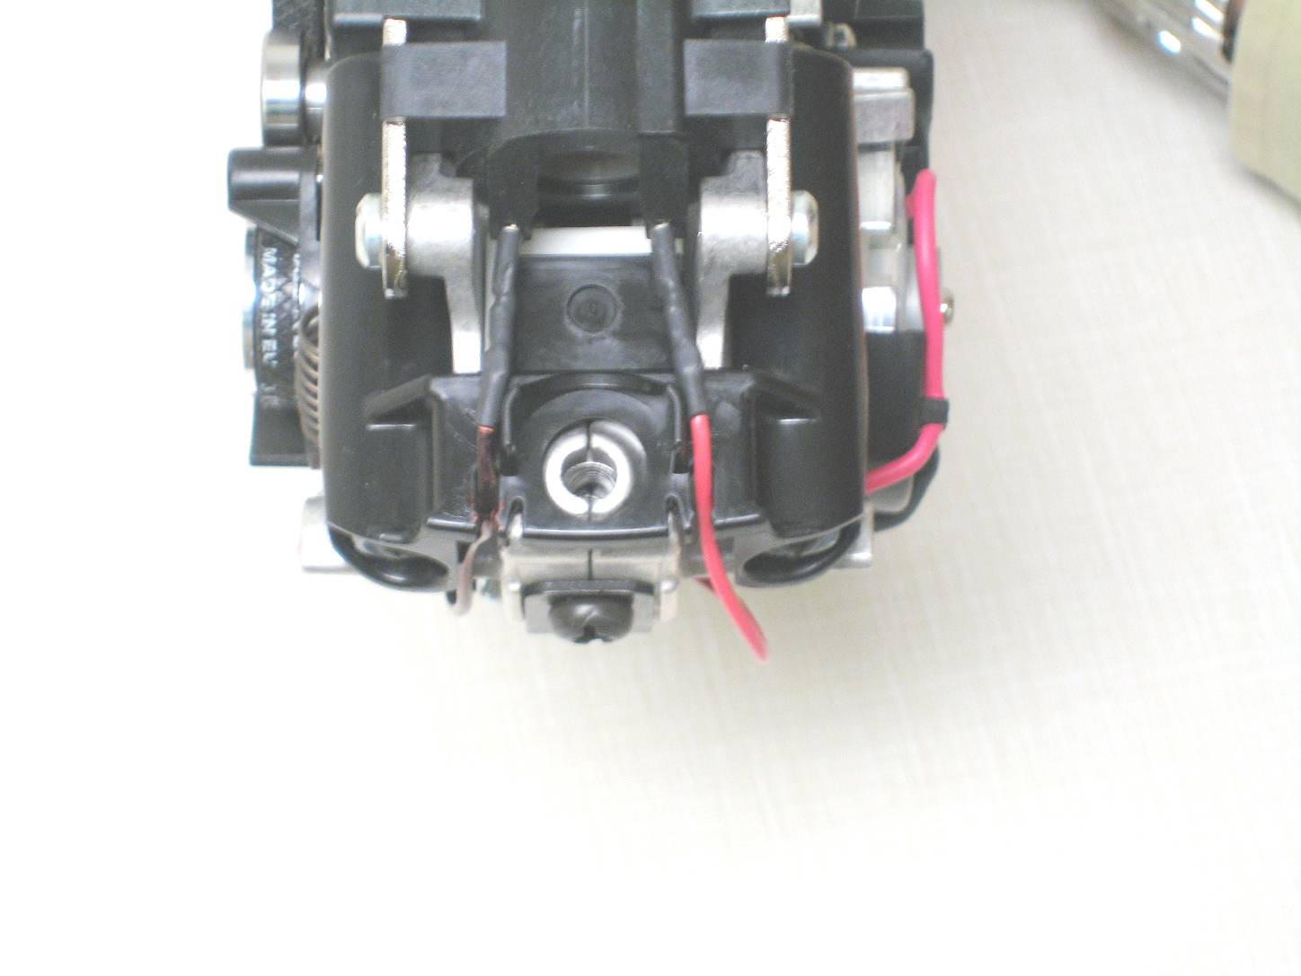
Black solenoids for 18v units White solenoids for 12v units

Attach both wires to the solenoid. Make sure the male terminals from the solenoid are inserted into the female connectors and not between the connectors and insulation.
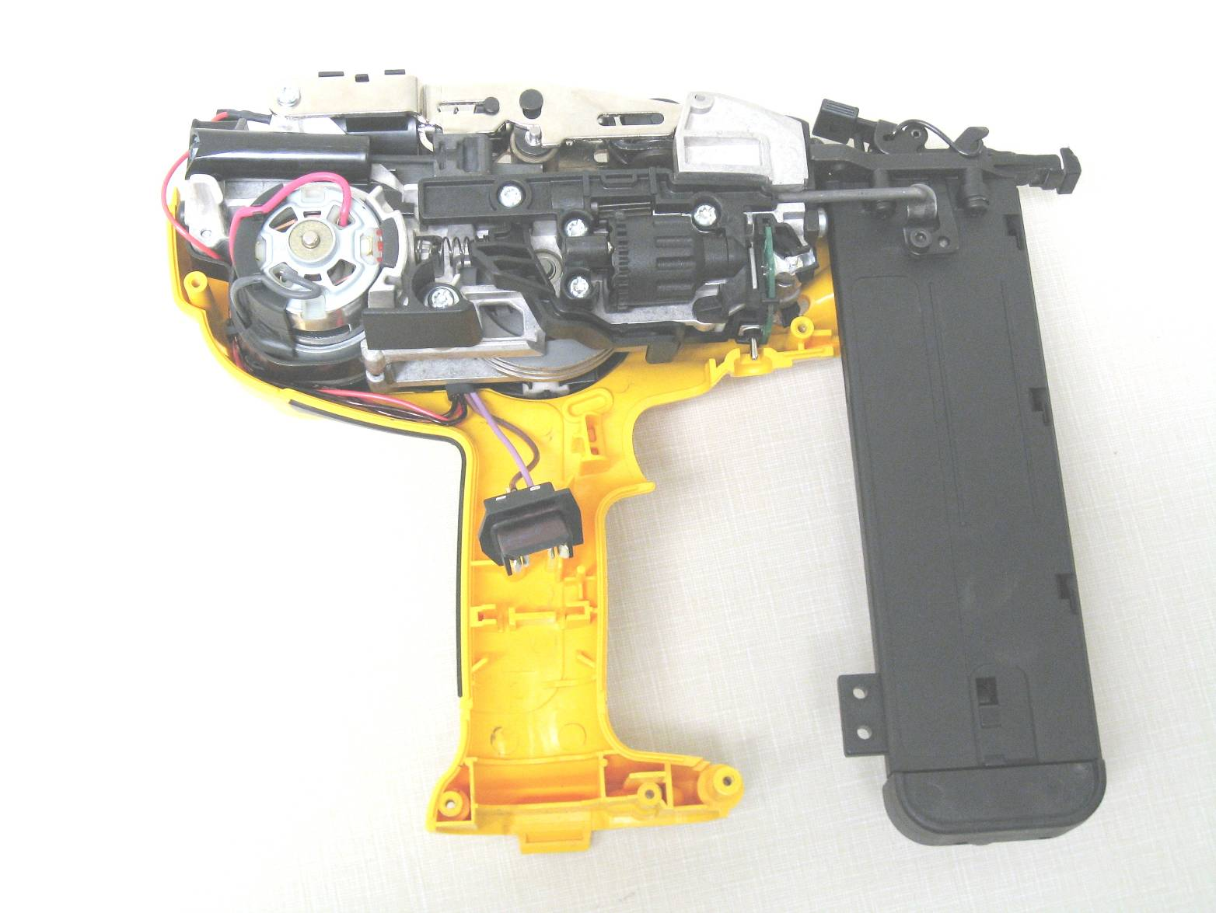
Make sure wires are tucked in housing

Once finished wiring, place the SA Engine in the housing assembly.
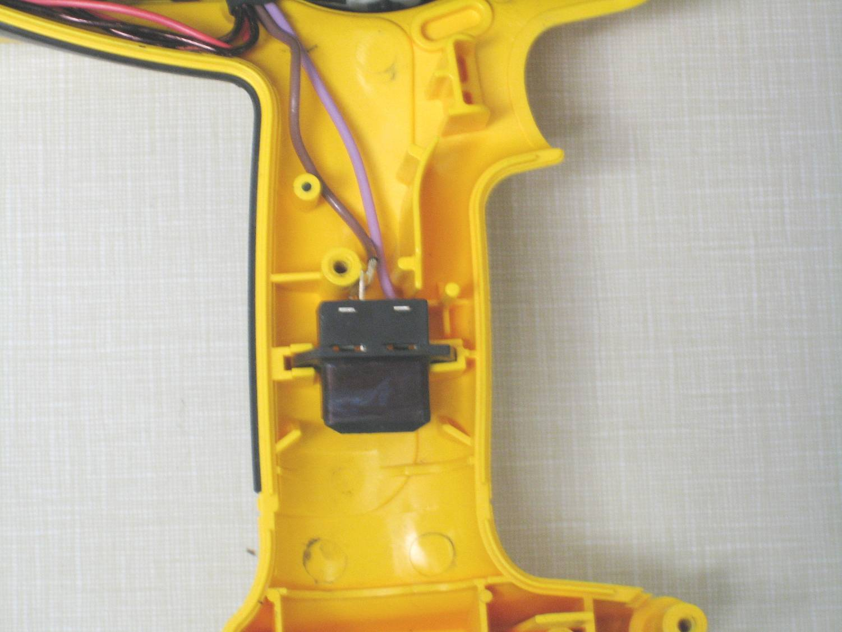
Brown wire should always be on the left side.
Purple wire should always be on the right side.

Slide the terminal block between the rib pattern on the housing.
Wire up diagram is finished and ready for the next step.

