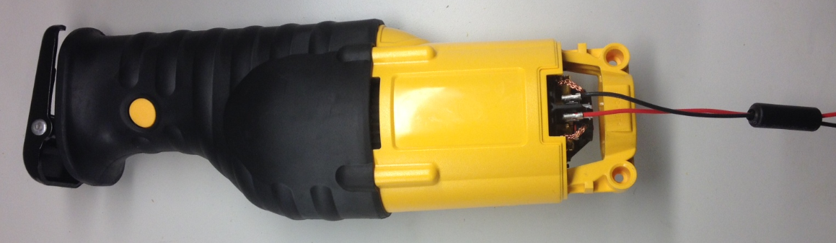 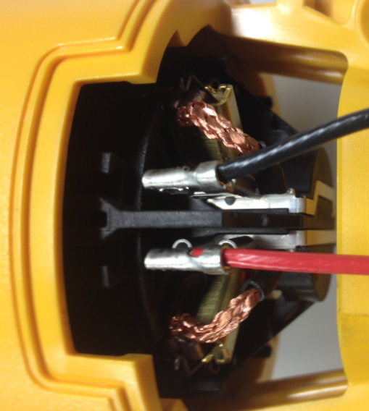

**BLACK LEAD WIRE CONNECTS TO TERMINAL WITH BENT BUS BAR**

**CONNECT RED LEAD WIRE FROM SWITCH TO BRUSH BOX MALE TERMINAL**

**CONNECT BLACK LEAD WIRE FROM SWITCH TO BRUSH BOX MALE TERMINAL.**

**3. PUSH WIRES INTO TRAPS AS SHOWEN**

**\*WHEN APPLICABLE ENSURE THE FERRITE BEAD IS LOCATED IN HOUSING POCKET.**

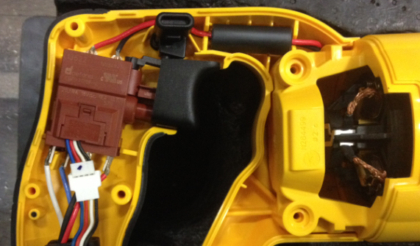

**1. PLACE MOTOR HOUSING INTO HANDLE ASSEMBLY HALF AS SHOWN**

**2. PLACE SWITCH INTO POSITION**

**ENSURE THE LEVER OF THE SWITCH POST IS ENGAGED IN THE LOCK-OFF BAR SLOT**

**INSERT LOCK-OFF BAR INTO POSITION AS SHOWN.**

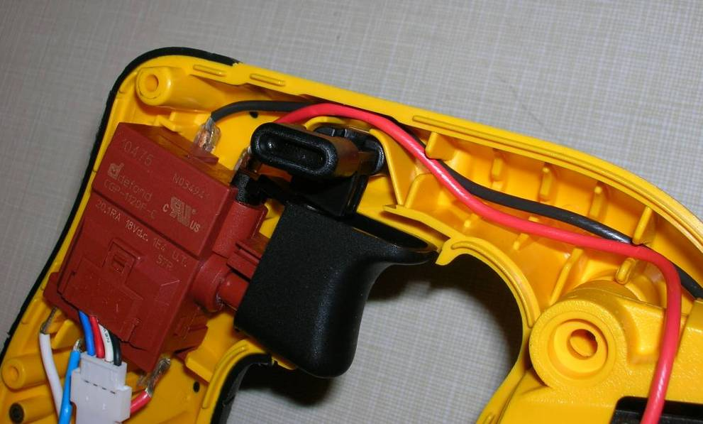

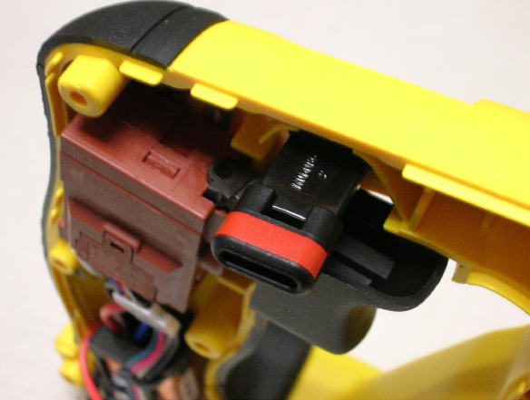

**INCORRECT**

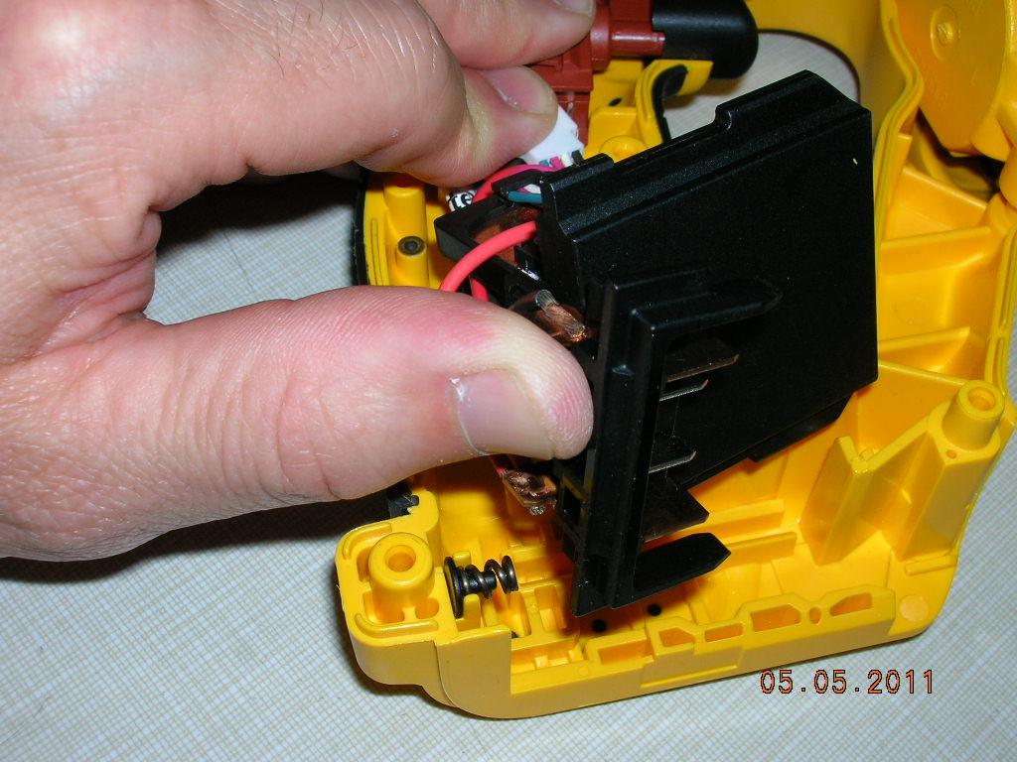

**INSERT SPRING AND SUPPORT INTO THE HOUSING SOCKET**

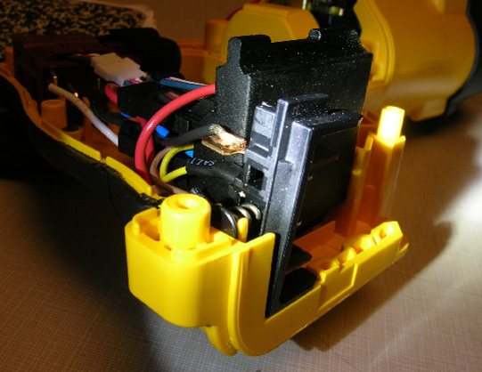

**2. INSERT THE MODULE BODY IN THE PROPER POSITION IN THE HANDLE**

**1. INSERT THE TERMINAL BLOCK IN THE PROPER POSITION IN THE HANDLE**

**INSERT SPRING INTO RECTANGULAR POCKET OF THE TERMINAL, WHILE PUTTING SUPPORT INTO THE NEST IN THE HANDLE**

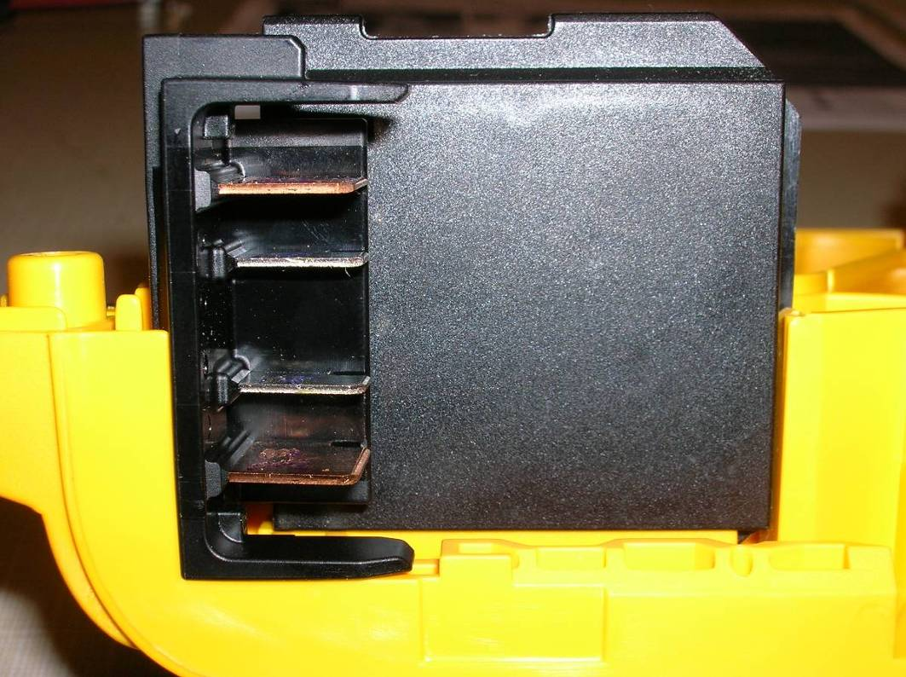

**\* ENSURE TERMINAL BLOCK AND MODULE ARE FULLY SEATED**

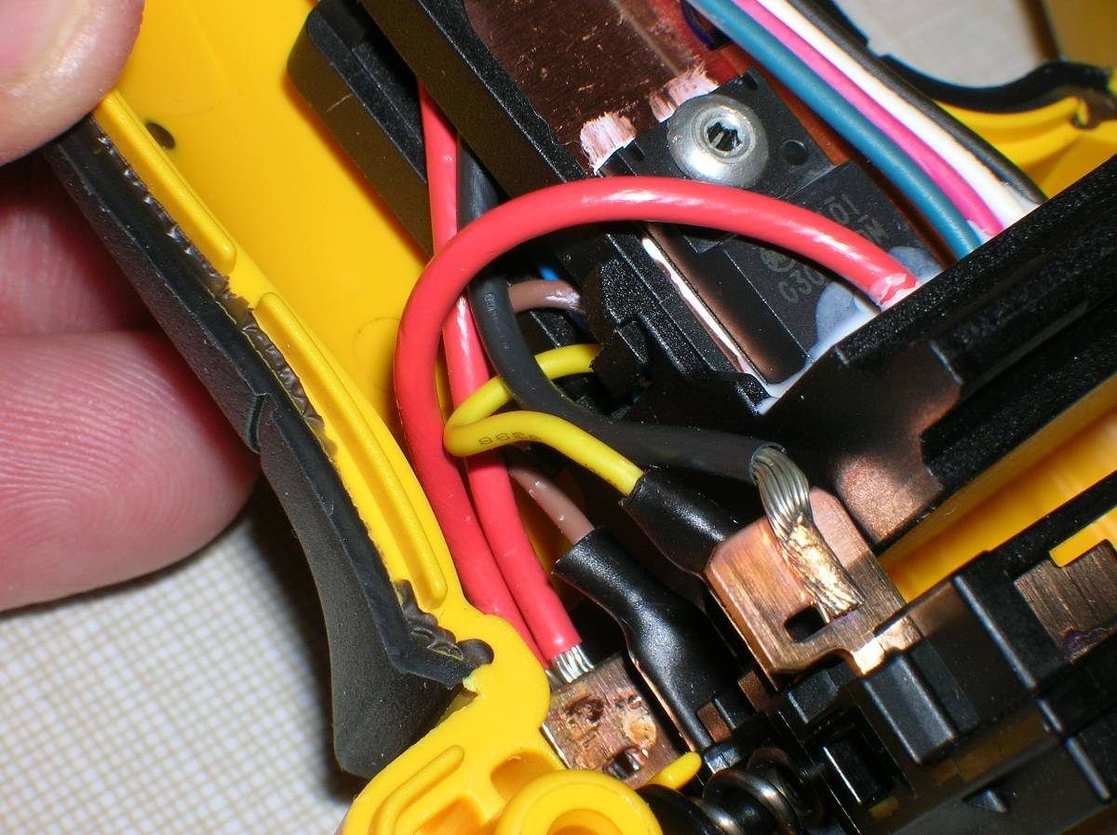

**ENSURE WIRES ARE NOT TANGLED OR KINKED, AND FREE FROM BECOMING PINCHED BY THE HANDLE COVER DURING ASSEMBLY**

**ENSURE EVERYTHING IS PROPERLY SEATED IN ITS PLACE PRIOR TO PLACING THE COVER ONTO THE ASSEMBLY**

